Marella Morad

73D
Quality Review and Reflection

Table of Contents
Introduction: 2
Unit Tests Execution: 3
AddMember component: 3
Member component: 3
MembersHome component: 3
Usability Testing Scenarios: 4
Test Case 1: Add a New Member in Less Than 2 Minutes 4
Test Case 2: Attempt to Delete a Member by Mistake and Recover Within 24 Hours 8
Conclusion: 11

Introduction:
After conducting a thorough review of the quality planning and review activities in accordance with Distinction Tasks 71D and 72D, I have gathered substantial evidence from both our JIRA board and GitHub Repository. The primary focus of this review was to assess two key metrics: Unit Tests, which serve as a means to verify the technical functionality of our system, and Usability Testing Scenarios, which provide valuable insights into the user-friendliness of our system, particularly with regard to our Member Management Web Pages. In this report, I will present the results of this quality review, shedding light on the strengths and areas for improvement in our software development process.
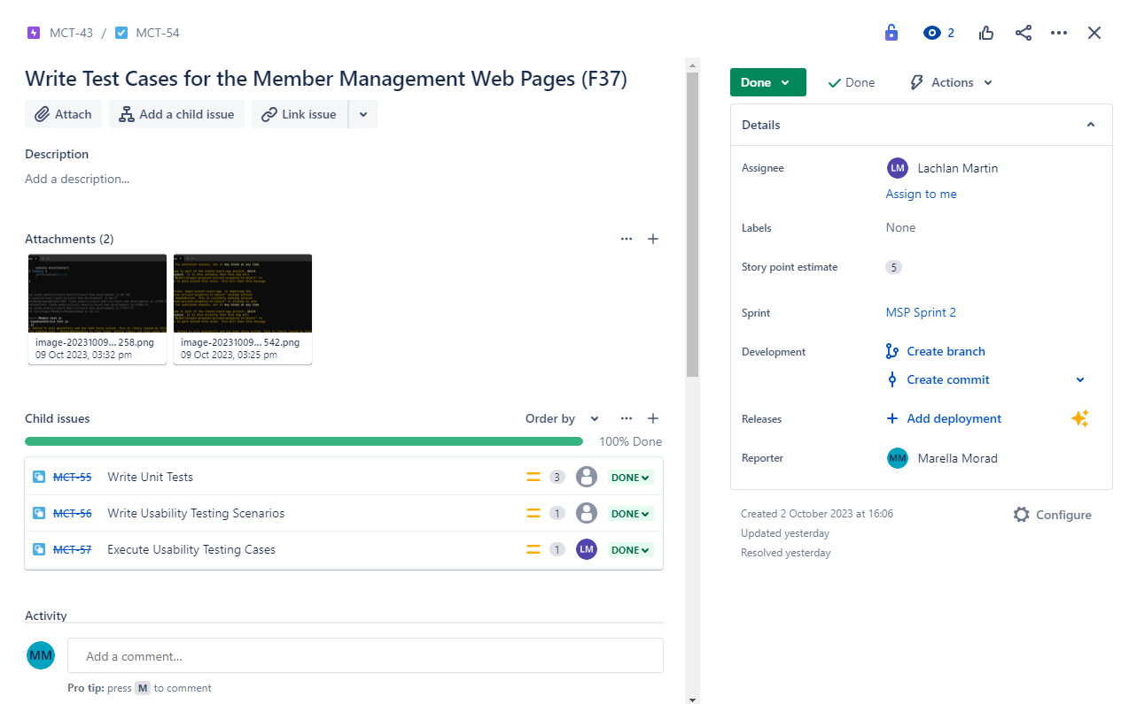

Unit Tests Execution:
As outlined in this Pull Request, I wrote test cases to internally test the member management web pages. The test cases include the following:

AddMember component:
- renders AddMember component: Checks if the AddMember component renders correctly with all the required input fields and buttons.
- adds a member: Simulates user input and tests if the addMember function is called with the expected data when the "Add" button is clicked.
- fails to add a member if required field is missing a value: Tests if the addMember function is not called when a required input field is left empty.

Member component:
- renders Member component: Ensures that the Member component renders correctly with member details, edit button, and delete button.
- edit member details: Simulates clicking the edit button, updating a member's details, and checks if the updateMember function is called with the expected data.
- soft delete member: Simulates clicking the delete button and checks if the softDeleteMember function is called with the correct member data.

MembersHome component:
- renders MembersHome component: Checks if the MembersHome component renders correctly with various UI elements like search bar, buttons, and title.
- searches for members: Tests the search functionality by simulating a search query and verifying that the searchMembersByName function is called with the correct search query.
- isLoading is true after handleSearch: Verifies that the "Loading..." message is displayed when the search button is clicked.
- saves selected member to local storage and navigates to the member page: Tests if selecting a member from search results saves their details to local storage and allows navigation to the Member page.
- retrieve recently deleted member (before 24 hours have passed): Tests the retrieval of a recently deleted member, including calling retrieveDeletedMember and checking if the selected member is saved to local storage.

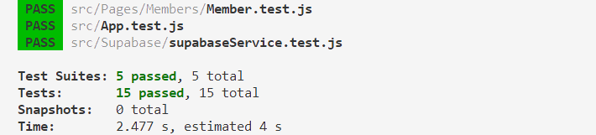
As can be seen above, all of the above tests passed.

Usability Testing Scenarios:

Test Case 1: Add a New Member in Less Than 2 Minutes
I executed the Outlined Steps as Per MCT-56 and found the following results:
- Navigate to GotoGro MRM.
- Log in with valid credentials.
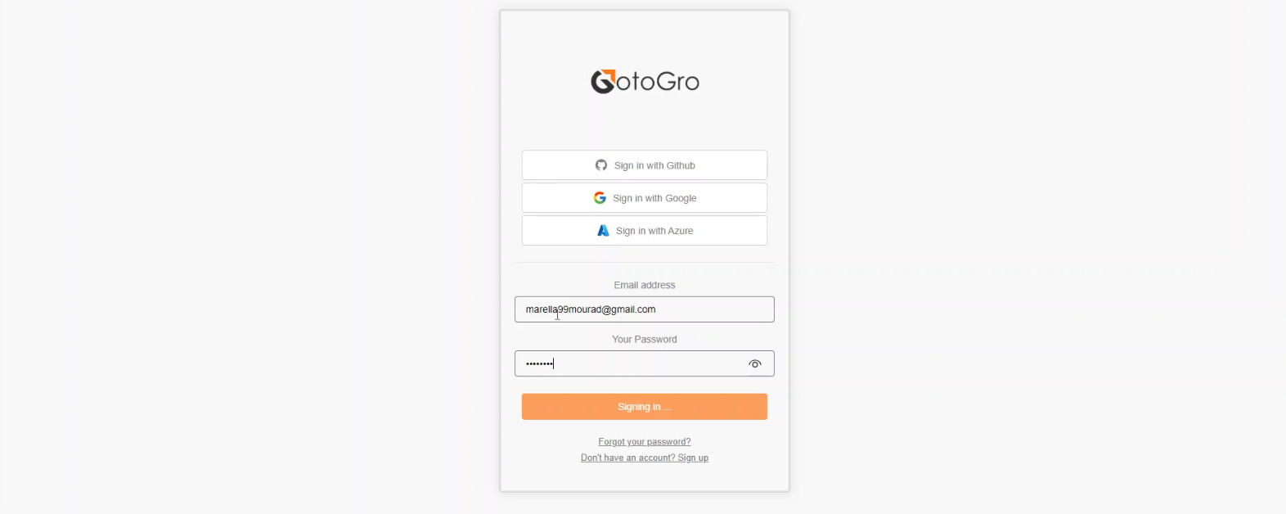
I was able to successfully login to GotoGro using credentials I signed up with a few days ago ✔.
- Start a timer to measure the time from starting the process to completing the submission.
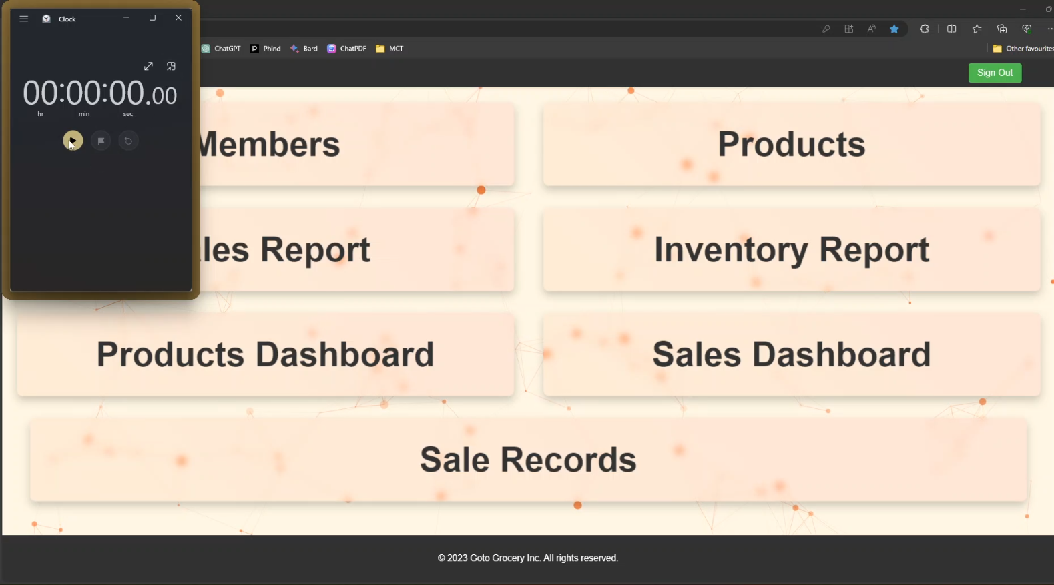
I started a timer as soon as the home screen of GotoGro loaded ✔

- Navigate to Members.
- Click on Add New Member.
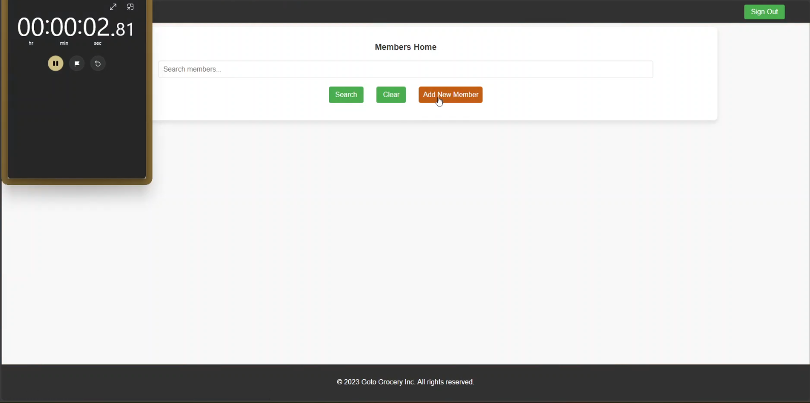
- Fill out the necessary member details (e.g., first name, last name and email).
- Verify that all required fields are clearly labelled and easy to find.
- Submit the form to add the new member.
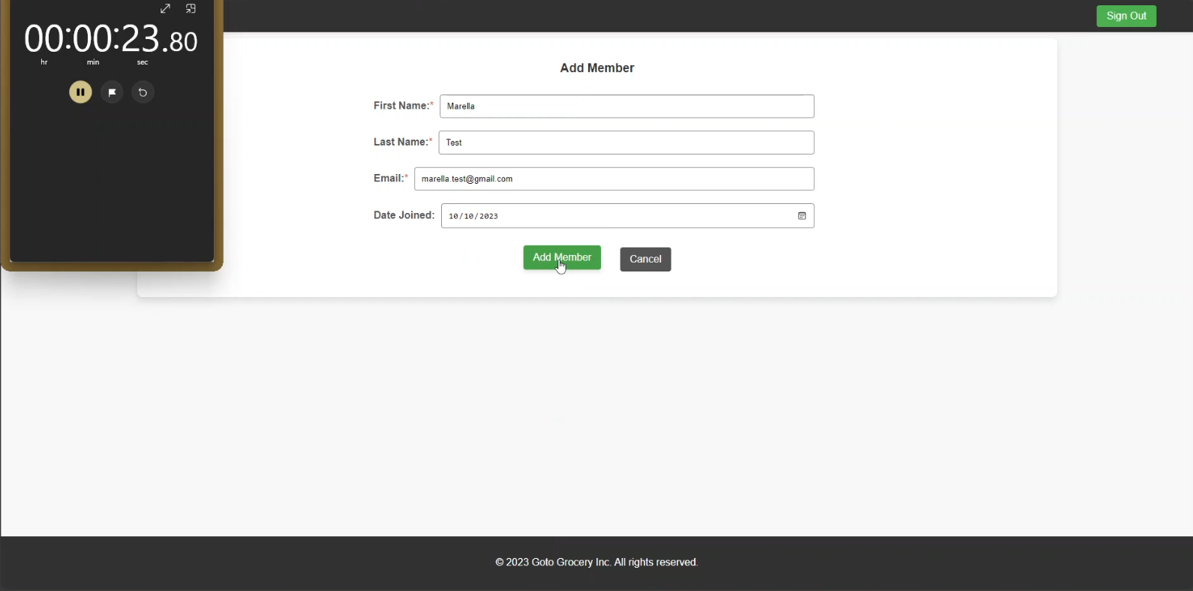

- Ensure that the entire process takes less than 2 minutes.
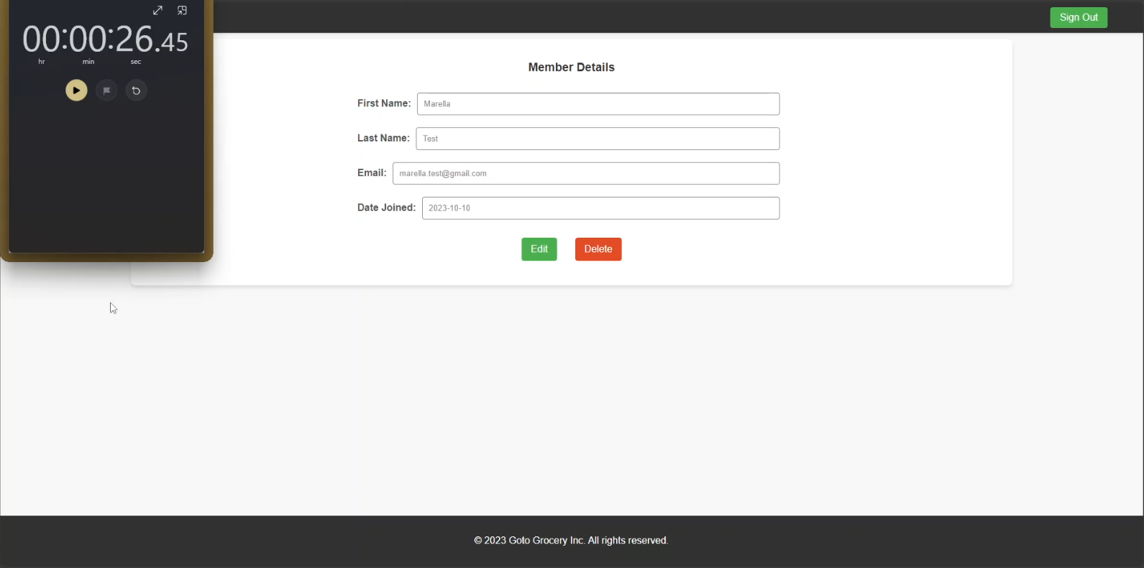
As shown above, adding a new member indeed takes less than 2 minutes; in fact, it takes less than 30 seconds. However, I conducted this test personally, and I consider myself an experienced user. Additionally, I developed the page, making it very familiar to me. Therefore, I have decided to ask someone else with no prior experience with GotoGro to perform the test.

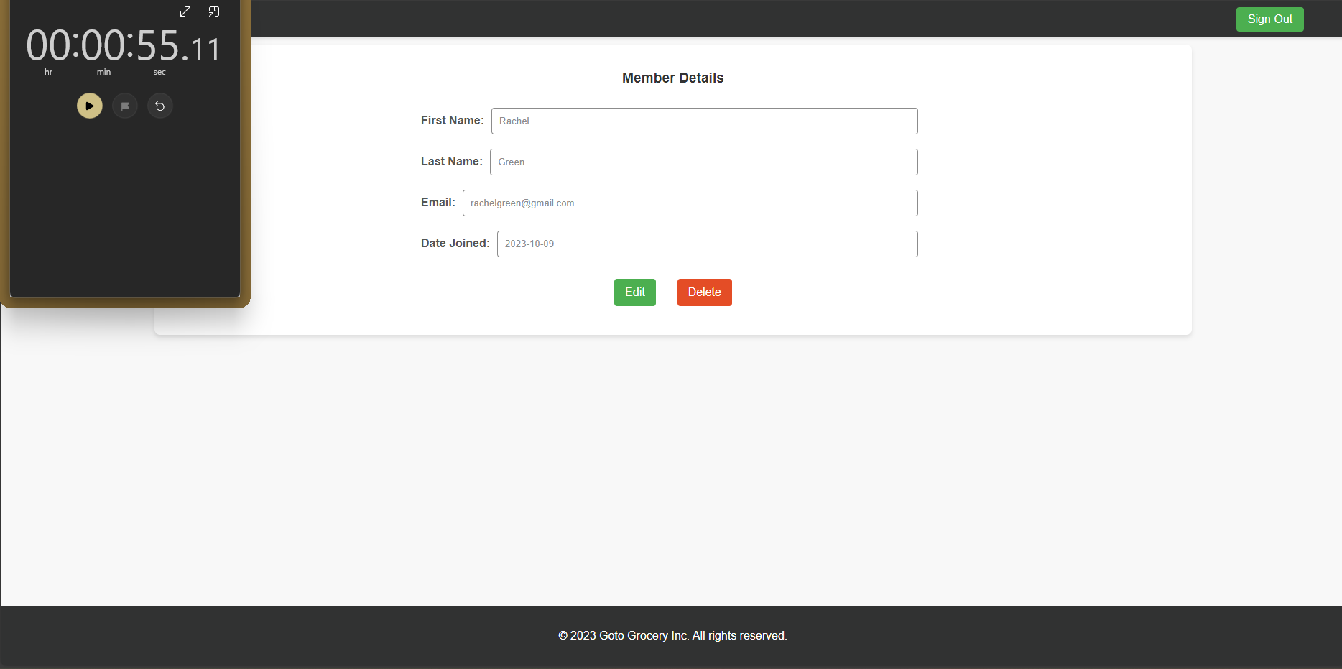
The other user was still able to add a new member within a minute, even after entering an invalid email address. The form prompted the user about the invalid email, and the user was able to save after entering a valid email. This outcome still meets the defined quality measure.
Expected Results:
- The system should allow users to add a new member in less than 2 minutes.
- The process should be straightforward and intuitive, with clear instructions and error handling.
Actual Results:
- The system allows users to add a new member in less than 2 minutes.
- The process is straightforward and intuitive, with clear instructions and error handling.

Test Case 2: Attempt to Delete a Member by Mistake and Recover Within 24 Hours
I executed the Outlined Steps as Per MCT-56 and found the following results:
- Navigate to GotoGro MRM.
- Log in with valid credentials.
- Navigate to Members Home.
- Enter a search term (or leave it blank) and click on Search.
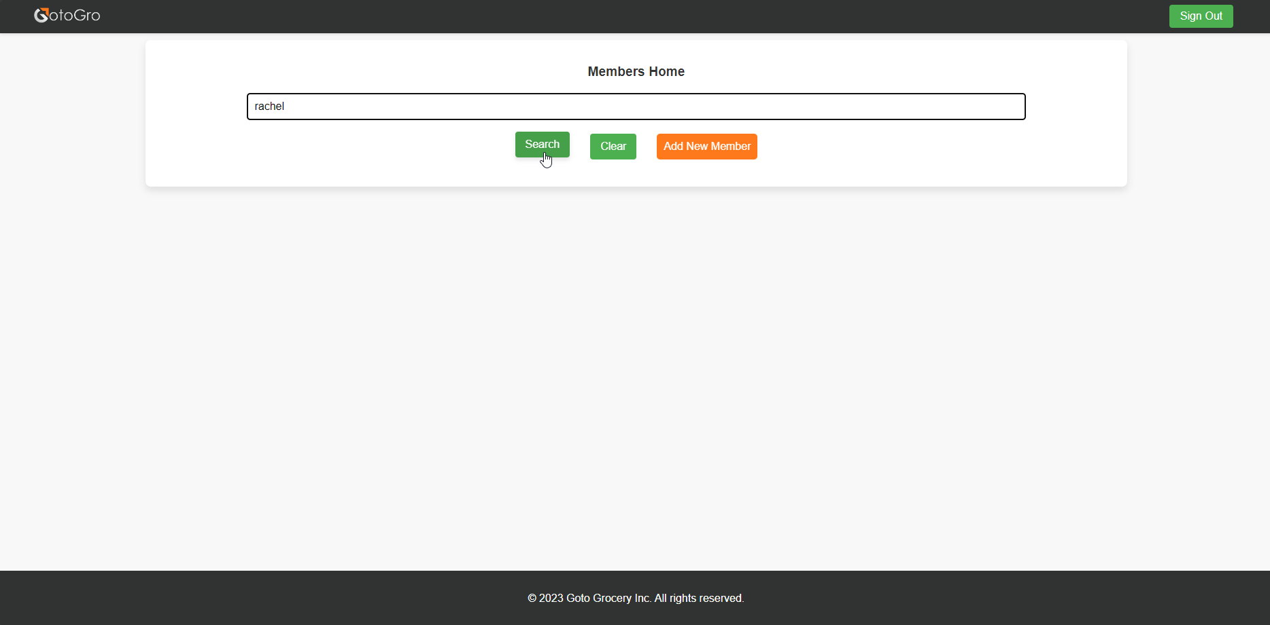
- Click on the View button of one of the found members.
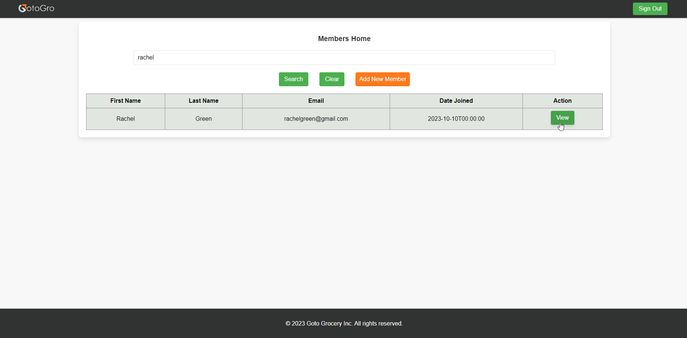

- Click on the Delete button from the Member Details screen.
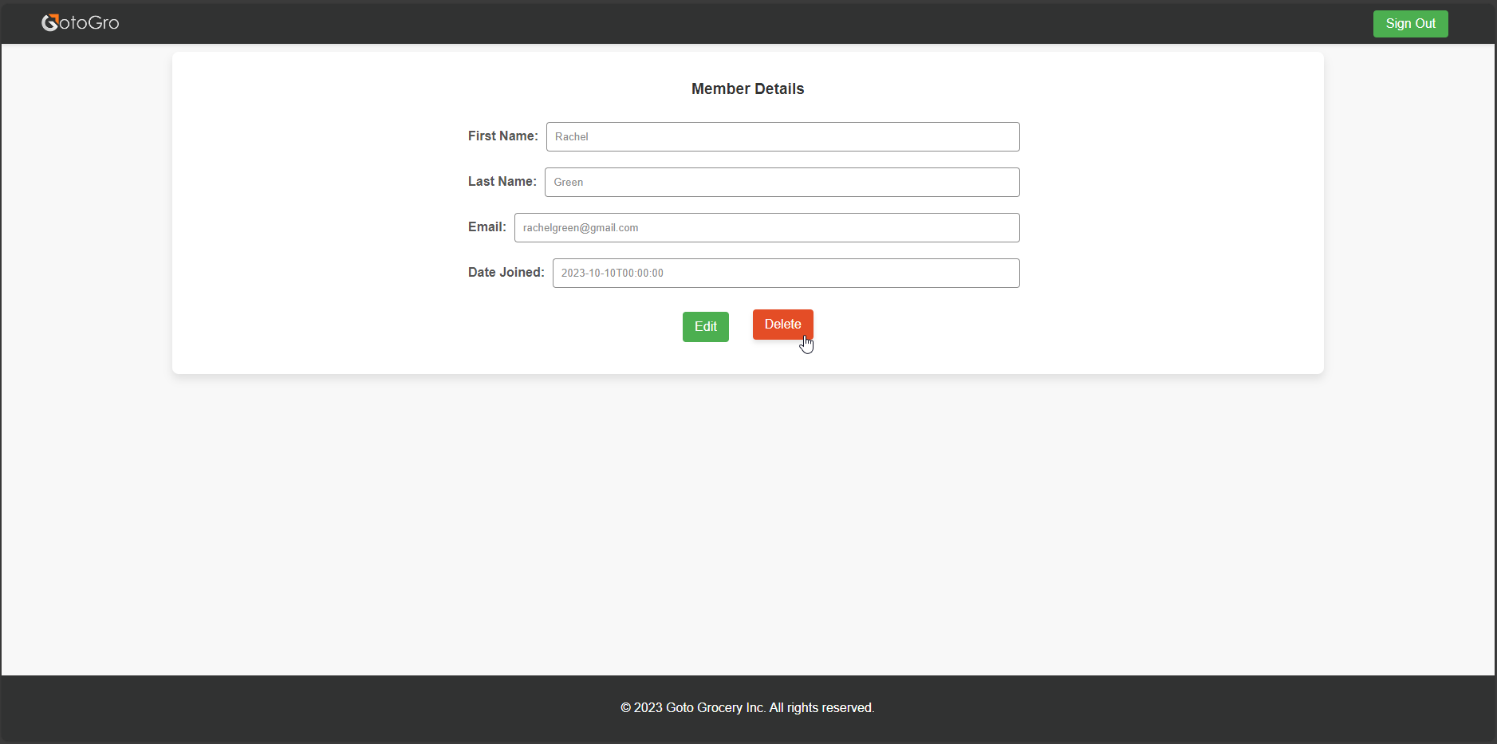
- Search for the deleted member from Members Home.
- Click on the Retrieve button to retrieve the deleted member record.
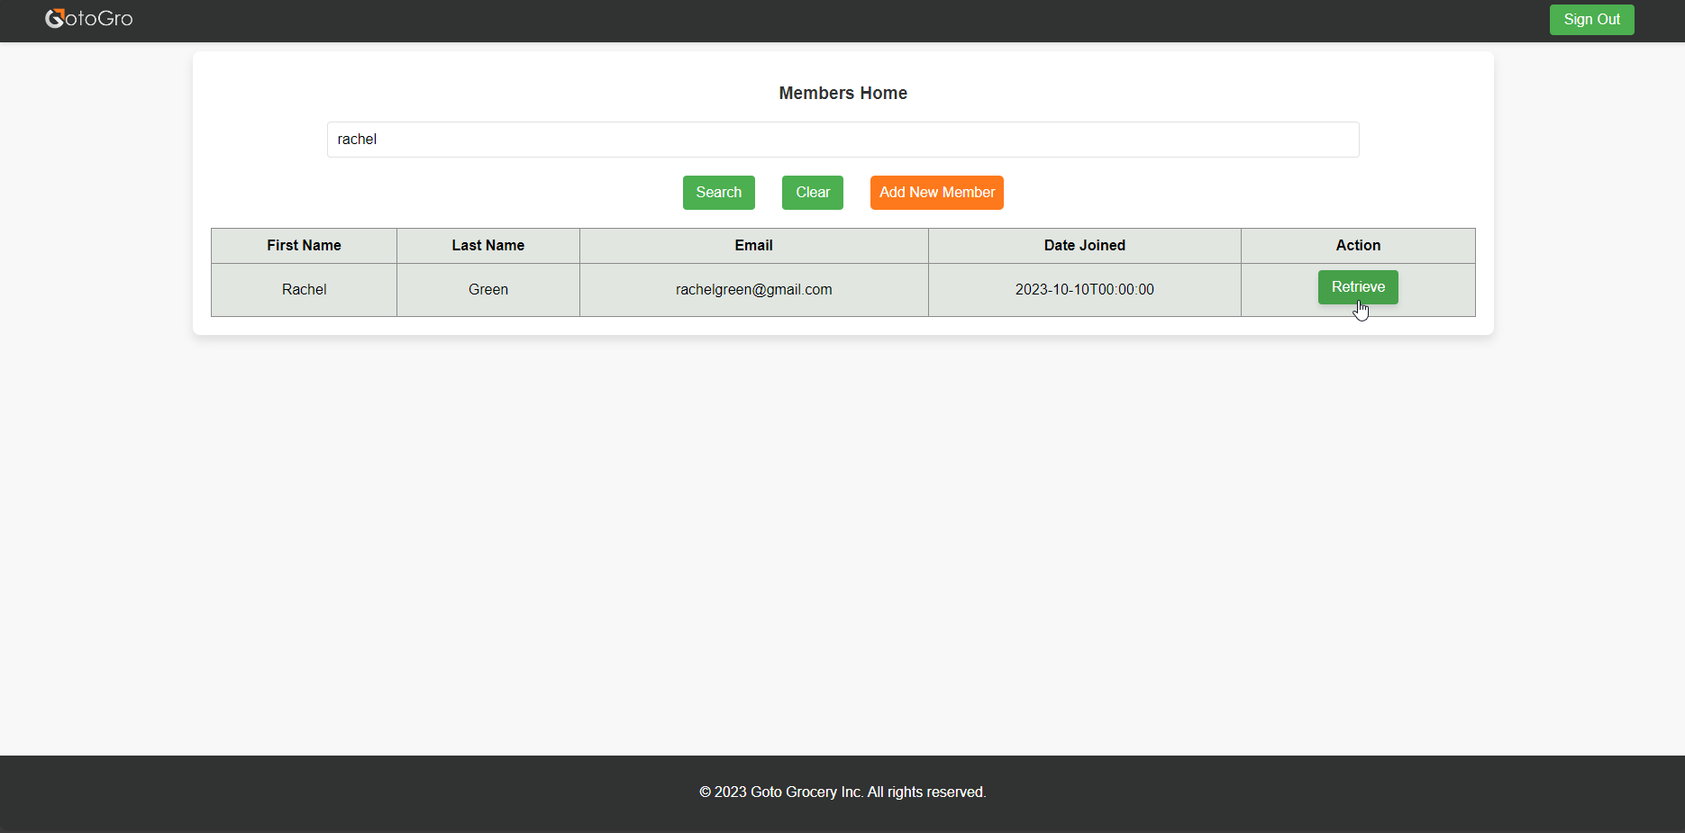

- Verify that the system allows you to undo the deletion and restore the member.
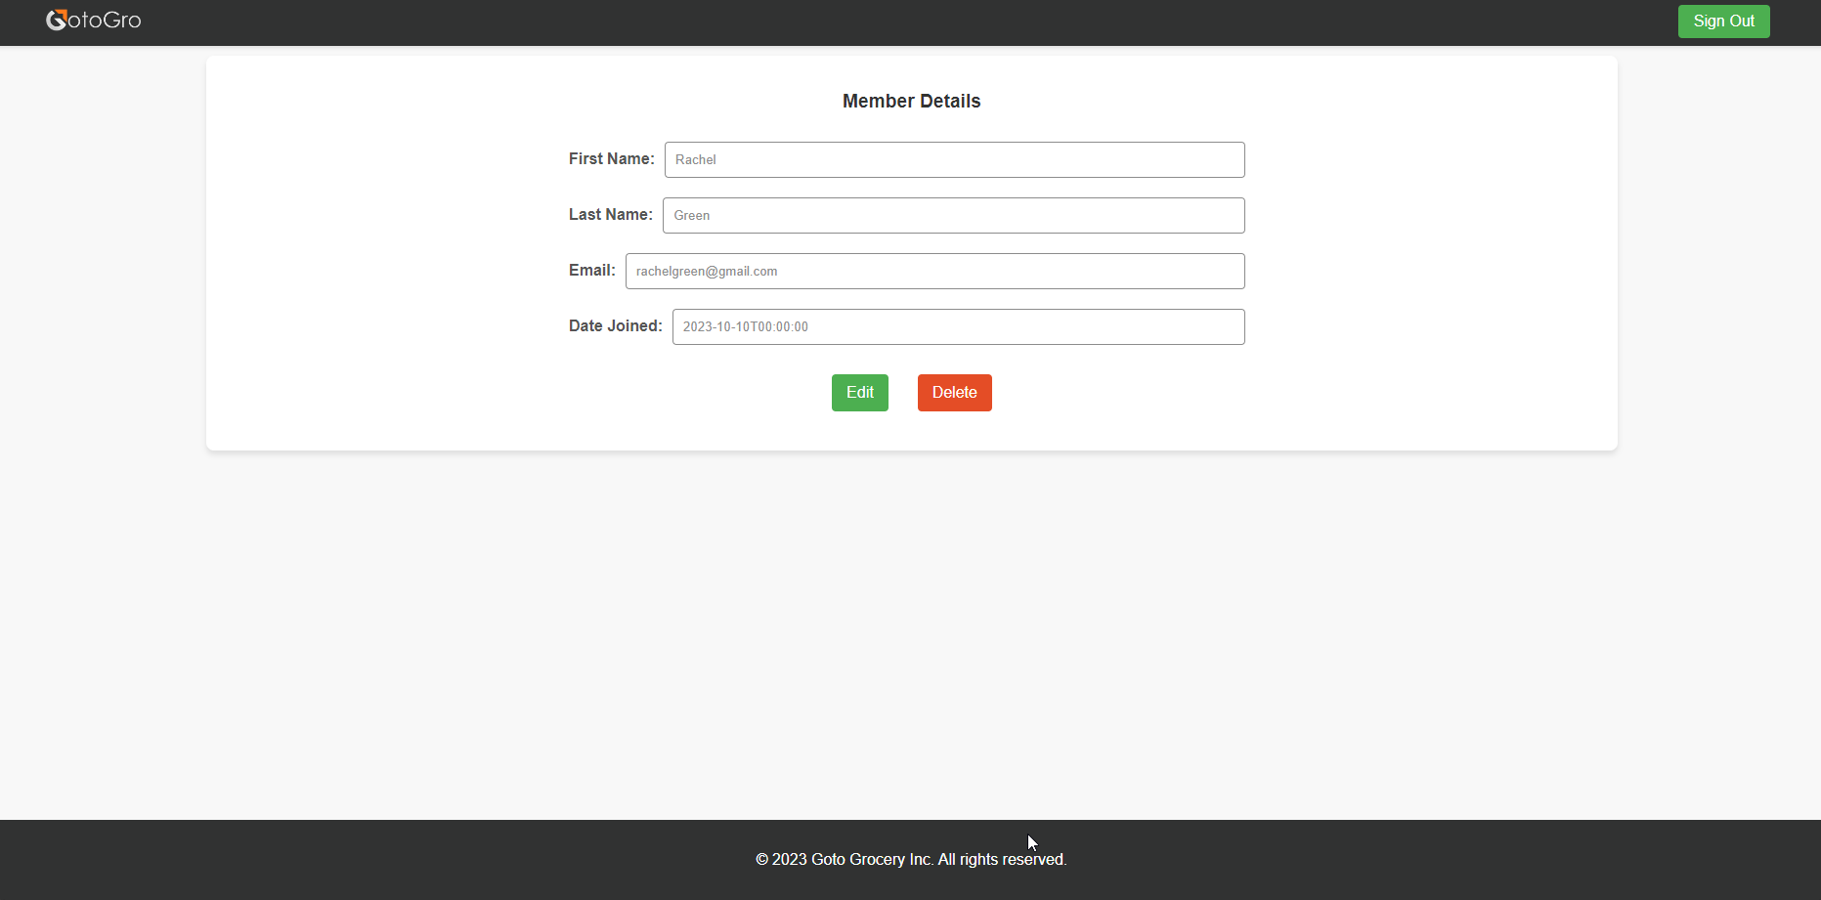
Expected Results:
- The system should offer an option to undo the deletion of a member within 24 hours.
- The process of recovering a deleted member should be straightforward and effective.
- Users should be able to recover a deleted member without significant delay or obstacles.
- Users should be navigated to the Member Details screen after Retrieving a soft deleted member.
Actual Results:
- The system offers an option to undo the deletion of a member within 24 hours.
- The process of recovering a deleted member is straightforward and effective.
- Users can recover a deleted member without significant delay or obstacles.
- Users are navigated to the Member Details screen after Retrieving a soft deleted member.

Conclusion:
The quality review for the defined metrics has yielded valuable insights into the efficiency of our Member Management Web Pages and our system's responsiveness to user actions.
For Metric 1, assessing the efficiency of adding a member, the threshold value was set at an average time of less than 2 minutes. Our actual value, as determined after quality assurance, demonstrates that experienced users can add a new member in a remarkably swift 30 seconds, while new users require approximately 1 minute. This result aligns well with our target, emphasizing the user-friendliness and efficiency of our system for this critical task.
Metric 2, which focuses on system recovery in case of member deletion by mistake, sets a threshold value for a "soft delete" feature, allowing user retrieval of deleted members within 24 hours without IT support intervention. Our actual value confirms that our system effectively provides this functionality, permitting users to retrieve deleted members within the specified 24-hour timeframe. This responsive and user-centric approach ensures that users can rectify accidental deletions without undue delay or inconvenience.
In summary, our software's performance in these two key metrics highlights its effectiveness and user-centric design. The efficient member addition process and responsive member recovery feature demonstrate our commitment to providing a streamlined and user-friendly experience for our users, ultimately contributing to the overall quality of our product.

